Committee on Contracts
Eric Bernstein, Counsel
Casie Addison, Policy Analyst

Committee on Small Business
Nicole Abene, Counsel
Michael Kurtz, Policy Analyst

Committee on Women’s Issues
Aminta Kilawan, Counsel
Joan Povolny, Senior Policy Analyst


THE COUNCIL OF THE CITY OF NEW YORK
Briefing Paper of the Governmental Affairs and Human Services Divisions
Matthew Gewolb, Legislative Director
Rachel Cordero, Deputy Director, Governmental Affairs Division
Terzah Nasser, Deputy Director, Human Services Division

COMMITTEE ON CONTRACTS
Hon. Helen Rosenthal, Chair

COMMITTEE ON SMALL BUSINESS
Hon. Robert Cornegy, Chair

COMMITTEE ON WOMEN’S ISSUES
Hon. Laurie Cumbo, Chair

December 5, 2016

Oversight: Update on the City’s Efforts to Expand Contracting with Minority and Women-Owned Businesses

- INTRODUCTION

On December 5, 2016, the Committee on Contracts, chaired by Council Member Helen Rosenthal, the Committee on Small Business, chaired by Council Member Robert Cornegy, and the Committee on Women’s Issues, chaired by Council Member Laurie Cumbo, will hold an oversight hearing on the City’s minority and women-owned business enterprises (“M/WBE”) program. The Committees last held a joint oversight hearing on M/WBE contracting in December 2015. Following that hearing, several local laws were enacted to promote transparency and accountability in the City’s M/WBE program. Today’s hearing will provide the Administration with an opportunity to update the Council on its efforts to increase City procurement opportunities for M/WBEs, and for advocates and affected businesses to share their experiences in contracting with the City. Those invited to testify include, the Mayor’s Office of Contract Services (“MOCS”), the Department of Small Business Services (“SBS”) and other interested parties.
- BACKGROUND
History of the City’s M/WBE Program
New York City is home to thousands of small businesses, including a significant number owned by minorities and women. According to the U.S. Small Business Administration, there has been a 31.9% increase in minority business ownership in New York State in recent years, and much of this has been driven by businesses in New York City. Despite the large presence of M/WBEs in the City, these businesses have traditionally struggled with participation in City contracting.
The City’s M/WBE program was originally established following a 1989 voter referendum approving the establishment of a program to assist M/WBEs. Pursuant to this referendum, in 1991, the Council enacted Local Law 61, which in part created the Division of Economic and Financial Opportunity within SBS, and authorized the Division to create an M/WBE program. The City regulations for the program provided that it would expire on June 30, 1998, unless the SBS Commissioner extended the program based on a finding that a continuation was necessary to address the impact of discrimination on opportunities for certified M/WBEs. After six years, the program expired in June 1998 as the City failed to conduct the required disparity study to determine the program’s continued necessity.
Despite the appropriation of funds by the Council for a new disparity study in 2000, 2001, and 2002, no study was conducted. Finally, in 2003, Medgar Evers College-CUNY was contracted to conduct a new study, which it commissioned from Mason Tillman Associates. Specifically, the study would examine the City’s procurement from 1997 to 2002 and determine whether a disparity existed between the availability of qualified M/WBEs and the utilization of M/WBEs in procurement during this time period. Released in January 2005, the study revealed significant demographic disparities among the business owners with whom the City contracts for purposes of receiving various goods and services. The study revealed that the City contracts with M/WBEs at drastically lower rates than businesses not owned by women or minorities. Further, the study examined the number of MWBEs that operate in the city compared to their rates of procurement of government contracts and found substantial underutilization. The study revealed that M/WBEs were underutilized in the awarding of both prime contracts and subcontracts.
Accordingly, that same year, the Council passed Local Law 129 of 2005, which re-established the City’s M/WBE program. The M/WBE program was designed to “address the impact of discrimination on the city's procurement process, and to promote the public interest in avoiding fraud and favoritism in the procurement process, increasing competition for city business, and lowering contract costs.” Local Law 129 set aspirational goals for City agencies to increase their contracting with MWBEs. These goals set target percentages for certain types of contracts, but initially, the law only applied to contracts valued at $1 million or less. Significantly, Local Law 129 created an M/WBE certification program, which provides greater access to information about contracting opportunities through classes, networking events, targeted solicitations, and includes an online directory for certified businesses within the City that promotes M/WBE businesses to purchasers.
After the program’s creation, certified M/WBE firms won more than three billion dollars in City contracts by 2012. Notwithstanding the successes of the M/WBE program under Local Law 129, amendments were made to strengthen the program. In 2013, the Council enacted, and Mayor Bloomberg signed into law, Local Law 1. Local Law 1 made a number of significant changes to the city’s M/WBE program, including: (i) removing the requirement that M/WBE goals only apply to contracts valued at one million dollars or less; (ii) the creation of “M/WBE stat,” an accountability program that requires agency M/WBE officers to convene quarterly to discuss progress with reaching M/WBE goals; (iii) requiring M/WBE reports from MOCS on a quarterly basis instead of semi-annually (as was required under Local Law 129 of 2005); and (iv) overall, improving and increasing education and outreach regarding the MWBE program and city contracting.
- CURRENT CITYWIDE CONTRACTING WITH M/WBEs
In Fiscal Year 2016 (“FY16”) the City’s total contracting budget was $15.3 billion dollars. Of the City’s total contracting budget, $4.55 billion dollars is subject to the M/WBE program. In FY16 the City achieved a combined prime and subcontract M/WBE utilization rate of 14% amongst contracts subject to Local Law 1, an increase from 8% in FY15. FY16 was the highest combined utilization under the City’s M/WBE Program. M/WBEs were awarded 13% ($609.3 million) of prime contracts in FY16 and 31% ($118.9 million) of subcontracts subjected to the program.
Although many agencies are subject to M/WBE participation goals, a significant percentage of the total value of citywide awards to M/WBEs were made by three agencies. The Department of Design and Construction (“DDC”), the Department of Parks and Recreation (“DPR”), and the Department of Environmental Protection (“DEP”) collectively awarded 66% of the total prime contracts and 91% of subcontracts to M/WBEs. DDC accounted for a significant portion of both prime and subcontract awards. In FY16, DDC awarded $251.2 million in prime contracts, an increase from $164.7 million in FY15, and $73.8 million in subcontracts, an increase from $26.3 million; more than any other agency.
Prime Awards to M/WBEs: Top 3 Agencies
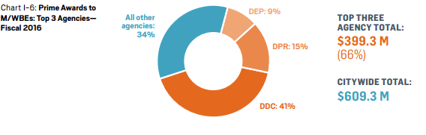
Subcontract Awards to M/WBEs: Top 3 Agencies
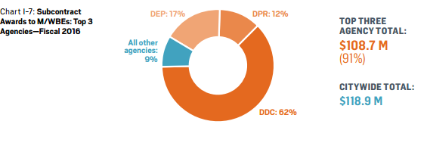
Source: Procurement Indicators Report Fiscal Year 2016
While certain agencies have contributed significantly to the City’s M/WBE efforts, analyzing each agency solely by the total value of their awards does not present a truly accurate assessment, as many agencies have budgets that are substantially larger than others. It’s important to note that while DDC awarded the greatest dollar value in awards to M/WBEs, the prime and subcontracts awarded by the agency represent only 18% and 27% respectively of its total contracting budget subject to the program.
In FY16, DDC had the largest prime contracting budget, compared to all other agencies at $1.4 billion. Although DDC awarded 18% ($251.1 million) in prime contracts to M/WBEs, it also awarded 82% (1.2 billion) to non-certified firms. Agencies with smaller budgets awarded a greater share to M/WBEs compared to agencies, like DDC, with considerably larger budgets. For example, the agency that awarded the highest percentage of its prime budget to M/WBE firms in FY16 was the Department of City Planning (“DCP”). DCP awarded M/WBE firms 62% of its $1.2 million prime budget. Notably, the NYC Department of Housing Preservation and Development (“HPD”) awarded 90% of its subcontracts to M/WBE firms. Comparatively, the Department of Environmental Protection (“DEP”) who had the second largest prime budget awarded 94% ($892 million) to non-certified firms and just 6% ($57 million) to M/WBEs. The figures provided in the Appendix illustrate the total amount in prime and subcontracts subject to the M/WBE program, each agency awarded to M/WBEs and non-certified firms.

- M/WBE AWARDS BY CERTIFICATION, INDUSTRY, RACE, AND GENDER
Awards by Certification & Industry

Firms included in the M/WBE Program can be certified as either a minority owned-business (“MBE”) or a women-owned business (“WBE”). Businesses owned by women of color can be certified as both and are listed as MBE/WBE. As part of the M/WBE program, businesses are contracted within four industries: construction, goods, professional services, and standard services. Of the $609.3 million in prime contracts awarded to M/WBEs, approximately 39.8% derive from construction contracts, 38.5% are from professional services, 15.13% from standard services, and 6.6% from goods. Of the $118.9 million in subcontracts awarded to M/WBEs, nearly 73% derive from construction contracts, 22.1% from professional services, and 5% are from standard services. In FY16, no subcontracts for goods were awarded to M/WBEs. Further, 92% of prime contracts awarded to M/WBEs were less than or equal to $20,000. Of the subcontracts awarded to M/WBEs, 97.34% were less than or equal to $1 million.

The tables below provide the total dollar amounts in prime and subcontracts awarded to each certification in FY16 by industry.
FY16- Total Value of Prime Contracts Awarded to M/WBEs by Industry
 | MBE | WBE | MBE/WBE | TOTAL MWBE
CONSTRUCTION | $76,284,942 | $175,629,030 | $9,442,569 | $242,471,402
GOODS | $18,931,916 | $25,106,924 | $3,787,585 | $40,251,255
PROF. SERVICES | $167,602,132 | $97,082,413 | $30,163,873 | $234,520,672
STANDARD SERVICES | $52,068,380 | $59,722,896 | $19,677,776 | $92,113,500
ALL SERVICES | $314,887,371 | $357,541,263 | $63,071,804 | $609,356,829
Source: Procurement Indicators Report FY16
FY16- Total Value of Subcontracts on Primes Awarded to M/WBEs by Industry
 | MBE | WBE | MBE/WBE | TOTAL MWBE
CONSTRUCTION | $55,552,490 | $34,848,826 | $3,701,478 | $86,699,838
GOODS | $0 | $0 | $0 | $0
PROF. SERVICES | $15,894,103 | $14,284,368 | $3,900,538 | $26,277,933
STANDARD SERVICES | $2,430,877 | $3,879,158 | $356,900 | $5,953,135
ALL SERVICES | $73,877,470 | $53,012,351 | $7,958,917 | $118,930,905
Source: Procurement Indicators Report FY16
Awards by Race and Gender

Although the City has generally improved it’s contracting with M/WBE firms, disparities exist among the type of MWBEs awarded contracts in various industries. While it appears that firms certified as WBEs received a greater share of prime contracts in construction, goods, and standard services (see the tables above), a significant percentage was solely awarded to white-women owned businesses.
In FY16 M/WBEs were awarded $242.5 million in prime construction contracts, 68.54% of which was awarded to white-women owned businesses. Similarly, of the total amount in prime contracts for goods and standard services awarded to M/WBEs, white-women owned businesses received 52.97% and 43.47% respectively. The only industry where white women-owned businesses did not receive an overwhelming share of the total amount awarded to M/WBEs for prime contracts was professional services. Of the $234.5 million awarded to M/WBEs for prime professional service contracts, businesses owned by Asian men were awarded approximately 40%. The pie charts below depict the percentage of total awards per industry and contract type firms owned by White Women, Asian Women, Black Women, Hispanic Women, Black Men, Asian Men, and Hispanic Men received in FY16.
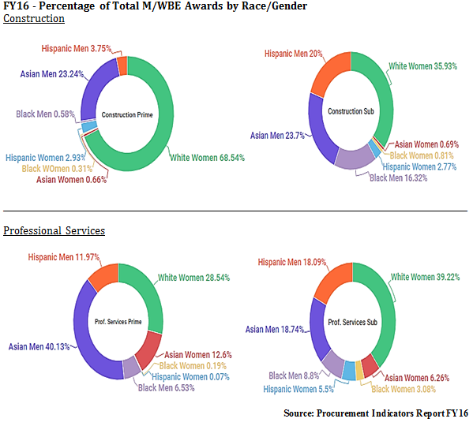
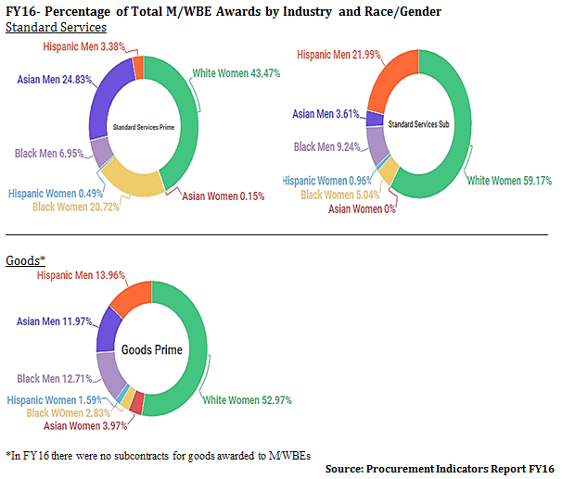
As the pie charts above depict, generally businesses owned by men and women of color received a higher percentage of awards for subcontracts than prime contracts, with the exception of businesses owned by Asian men. However, this difference is not as significant for businesses owned by women of color as it is for those owned by men. Businesses owned by women of color were awarded significantly less in all industries and contract types compared to all other groups. Of the total amount in prime contracts awarded to M/WBEs citywide ($609.3 million), 1.37% was awarded to Hispanic women-owned businesses, 3.52% to Black women-owned businesses, and 5.46% to Asian women-owned businesses.
Further, the percentage of total subcontracts awarded to M/WBEs citywide was even less for businesses owned by women of color. In FY16 M/WBEs were collectively awarded $188.9 million in subcontracts, of this 1.89% was awarded to businesses owned by Asian women, 1.52% to businesses owned by Black women, and 3.28% to businesses owned by Hispanic women. The pie charts below illustrate the share of the total citywide amount in prime contracts ($609.3 million) and subcontracts ($188.9 million) awarded to M/WBEs by race and gender.
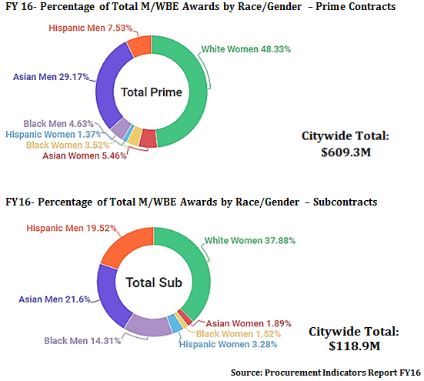
From the current data made accessible by the Administration, it is unclear how the proportion of certified firms impacts the distribution of awards. For example, more white-women owned firms could be certified than other groups, which could possibly explain why they were awarded a greater share of contracts. Additionally, there are a myriad of challenges M/WBEs experience when trying to contract with the City. These findings may provide a deeper understanding of which M/WBEs are experiencing the challenges mentioned in the following section at greater rates.
- CHALLENGES CONTRACTING WITH M/WBEs
Although New York City is home to the largest and most diverse population of businesses in the United States, M/WBE contracts do not reflect this diversity. A number of issues have been ongoing in relation to success of this program. Failure to meet participation goals, fraud, abuse, oversight and accountability pose significant challenges.
In April 2015, The Black Institute (TBI) issued a report, entitled “Not Good Enough: They Myth of Good Faith and Bad Efforts”, which pointed to several areas that are problematic. TBI suggests that the barriers M/WBEs experience include, but are not limited, to securing start-up capital, racial and gender bias, a difficult M/WBE certification process, a lack of sufficient information tools for M/WBEs to compete for government contracts, and delays in payments from contracting agencies.
Furthermore, a number of industries, including but not limited to construction, are historically dominated by men, and would require a more concerted effort in training and recruitment to create a pipeline for women to benefit from the program in these fields.
Another significant challenge is the limitation on the City’s ability to target procurements to M/WBEs as a result of State law. Most prime contracts covered by the City’s M/WBE program are subject to New York State General Municipal Law §103, which requires them to be procured through competitive sealed bidding and awarded to the lowest responsible bidder. State law also requires many contracts not covered by this statute, such as professional services contracts, to be awarded “to assure the prudent and economical use of public moneys in the best interests of the taxpayers of the political subdivision or district, to facilitate the acquisition of goods and services of maximum quality at the lowest possible cost under the circumstances, and to guard against favoritism, improvidence, extravagance, fraud and corruption.” Therefore, the City is prohibited from explicitly attaching social policy goals, such as increasing the number of contracted M/WBEs, to the procurement of goods and services. Under these restrictions, according to the Administration, citywide M/WBE goals “must be viewed as aspirational.”
Legislation has been advanced through the State Legislature in recent years to address these limitations, including bills sponsored by Assemblywoman Rodneyse Bichotte and Senator James Sanders that would increase the City’s M/WBE discretionary spending on small purchases, allow M/WBE status to be a factor in “best value” awards, establish capacity building programs to benefit certified M/WBEs, and permit pre-qualified lists for purchase contracts (in addition to public works contracts). This legislation was passed by the Assembly but not the Senate.
- CITY PROGRAMS TO ASSIST M/WBEs
New York City provides capacity-building programs and services for small businesses, including M/WBEs and also specifically for M/WBEs, many of which are discussed below.
NYC Business Solutions helps small businesses, including M/WBEs, across all industries secure low-rate loans to compete on City contracts. Account Managers will assist businesses through the process of securing the financing they need.
The City also provides technical assistance through access workshops, industry specific group sessions, and one-on-one guidance to help small businesses, including M/WBEs, increase industry knowledge and win more contracts. This technical assistance benefits businesses that work in construction; goods and manufacturing; standard services; and professional services. Workshops assist businesses with deciding how to price their bid, submitting proposals that meet City requirements, as well as holding industry specific sessions and tailored group sessions. One-on-one assistance is also available to guide firms in the process of bidding on a City contract, as well as assistance reflecting on unsuccessful bids and evaluating past proposals.
NYC Teaming offers a series of workshops and business matchmaking events where small businesses, including M/WBEs can connect and work toward larger opportunities together than they would be able to bid on alone. Construction firms can receive bond readiness training, including one-on-one assistance to attain surety bonds or increase surety bonds on City construction projects.
In addition to general small business programs, certain programs are designed specifically for M/WBEs. NYC Construction Mentorship is a program in which business owners can learn how to better manage businesses, connect with contract opportunities, expand professional networks, and receive mentors to assist in growing their businesses. In addition, the NYC Goods and Services Mentorship offers customized guidance for better business operations, practices, and growth through City contracting opportunities for M/WBEs in non-construction industries. This is an 8-month long program, which includes a business needs assessment and customized growth plan developed with an experienced business management firm, a curated curriculum, one-on-one mentorship, and access to technical assistance.
Another education program for M/WBE owners who want to grow their business is Strategic Steps for Growth (SS4G). SS4G has helped almost 100 M/WBE owners since 2010 develop a plan for growth through an evening class taught by an NYU professor, peer-mentorship, advice from expects, and a supportive alumni network. This program is application-only and while it is valued at $10,000, the cost in tuition to participating M/WBE owners is $1,000.
Thirteen corporate partners have teamed up with SBS to offer three programs that involve working directly with M/WBEs under the umbrellas of the Corporate Alliance Program (CAP). The M/WBE Referral Service is a partnership between SBS and corporate partners to refer M/WBEs for specific private and public contracting opportunities. In addition, CAP provides a mentorship program that works over 28 weeks to assist businesses in growing, as well workshops to provide insight on how best to do business with these corporations.
- STATE AND FEDERAL PROGRAMS TO ASSIST M/WBEs
New York State offers programs to assist M/WBEs as well. To make low-cost financial assistance available to minority and women-owned businesses that may be unable to access traditional financial services, the State created the Minority and Women Revolving Loan Trust Fund Program through Empire State Development. To date, this program has capitalized loan pools that total more than $3.5 million for 12 community-based economic development organizations located throughout the state. The capital loans provided are up to $35,000 and fixed asset loans of up to $50,000. These businesses are also offered technical assistance, including loan application completion, business development, mentorship, and credit union services.
The Federal government through the US Small Business Administration (SBA) also runs mentorship programs, one-to-one counseling, training workshops, and management and technical guidance for minority-owned businesses, as well as providing access to government contracting opportunities for these businesses. SBA enables economically disadvantaged women-owned small businesses (EDWOSBs) to compete for federal contracts that are set aside for EDWOSBs in industries where women-owned small businesses are substantially underrepresented.

- RECENT EFFORTS TO ADDRESS ISSUES INVOLVING THE M/WBE PROGRAM
In September of 2015, Mayor Bill de Blasio announced that New York City awarded over $1.6 billion in contracts to M/WBEs in fiscal year 2015. The Administration contends that it is working to achieve its goal of awarding $16 billion in M/WBE contracts over a ten-year period. However, the Administration has publically recognized the legal challenges the City has faced with increasing M/WBE procurement, and accordingly announced in May 2015 that the Administration would push the State legislature to amend State law to permit the City to make necessary changes to its M/WBE program. The Mayor contended that such changes would increase M/WBE procurement and include raising thresholds for discretionary spending, expanding the use of ‘best value’ procurement and expanding the usage of M/WBE-related pre-qualified lists to all industries.
The Council enacted several laws in September 2016 to address concerns about transparency and promote accountability in the M/WBE program. These included measures to codify the City’s M/WBE advisory board, mandate training for all agency chief contracting officers and M/WBE officers, require the reporting of information on whether recipients of economic development benefits through the New York City Economic Development Corporation (EDC) are meeting M/WBE goals, publish agency M/WBE utilization plans online for public access, amend the City’s M/WBE reporting requirements for greater clarity, and provide more information about the City’s Chief Procurement Officer’s determinations on whether large contracts can be divided to enhance competition for M/WBEs and other bidders. Mayor de Blasio signed these measures into law later that month.
Mayor de Blasio also took action pertaining to M/WBEs in September of 2016. He announced a 30% MWBE participation goal by 2021 and appointed Deputy Mayor of Strategic Initiatives Richard Buery – who had previously implemented Mayor De Blasio’s Pre-K for All initiative – as the new MWBE director for the City. The objective is that 30% of the dollar amount of city contracts will go to MWBEs by 2021, which would include subcontracts with mayoral and some non-mayoral agencies. In Fiscal Year 2016, MWBEs were awarded 14% of all contract dollars, which is nearly double the eight percent awarded the previous fiscal year. In the longer term, the Mayor intends to award $16 billion in contracts to MWBEs by 2025 and, by 2019, to double the number of certified and re-certified MWBES at SBS from 4,500 to 9,000. The Mayor will also be pursuing legislative initiatives in Albany in conjunction with this agenda. The City is currently required to award contracts over $35,000 to the lowest responsible bidder, while the State has more flexibility in awarding contracts under $200,000. Mayor de Blasio is seeking changes that would give the City the same $200,000 threshold as the State.
However, the Administration’s M/WBE program has received ongoing criticism from other elected officials and advocates. City Comptroller Scott Stringer has been a frequent critic of the Administration’s M/WBE efforts. The Comptroller’s annual M/WBE report, Making the Grade, grades City agencies (and the City overall) based on their level of M/WBE spending (as opposed to contracting) in the given fiscal year. In FY 2016, the Comptroller’s office gave the City a D+ for its efforts. Specifically, the report argued that only 4.8 percent of the City’s procurement of goods and services went to M/WBEs, and only 994 of the 4,527 certified M/WBEs received City spending on goods and services. The Comptroller awarded grades of “D” and “F” to nearly half of the 32 graded agencies, and an “A” to only one.
Bertha Lewis of the Black Institute has argued that New York City should amend Local Law 1 to increase the share of contracts awarded to M/WBEs to 35%, expand MWBE requirements to all City agencies, and employ a full-time chief diversity officer. Additionally, in November 2015, when Mayor de Blasio and Public Advocate Tish James announced that the city would create a $10 million predevelopment loan fund as well as a $10 million bond fund to facilitate financing for growing firms as they launch projects, a number of major M/WBE developers deemed the amount of funding insufficient. Business leaders have stated that the City’s M/WBE program is not aggressive enough to meet the significant challenges facing minority contractors, as it does not provide enough assistance to help more established firms compete for projects “at the highest levels” and does not commit sufficient money to bond and loan funds.

APPENDIX – M/WBE PROGRAM FY 2016
Appendix List of Tables:
Total Prime Contracts Awarded to M/WBEs and Non-Certified Firms by Agency
Figure A- Agencies with a total prime budget between $400 million and $1.4 billion

Figure B- Agencies with a total prime budget between $50 million and $160 million

Figure C- Agencies with a total prime budget between $12 million and $40 million

Figure D- Agencies with a total prime budget between $1 million and $7.5 million

Figure E- Agencies with a total prime budget greater than $190 thousand, but less than $1 million

Total Subcontracts on Primes Awarded to M/WBEs and Non-Certified Firms by Agency

Figure F- Agencies with a total of subcontracts on primes greater than $200 million

Figure G- Agencies with a total of subcontracts on primes between $30 million and $50 million

Figure H- Agencies with a total of subcontracts on primes between $3 million and $7.1 million

Figure I- Agencies with a total of subcontracts on primes less than $600 thousand

FIGURE A:
FY16- Total Prime Awarded to M/WBEs and Non-Certified Firms by Agency*
*includes agencies with a total prime budget between $400million and 1.4billion, subject to the M/WBE Program
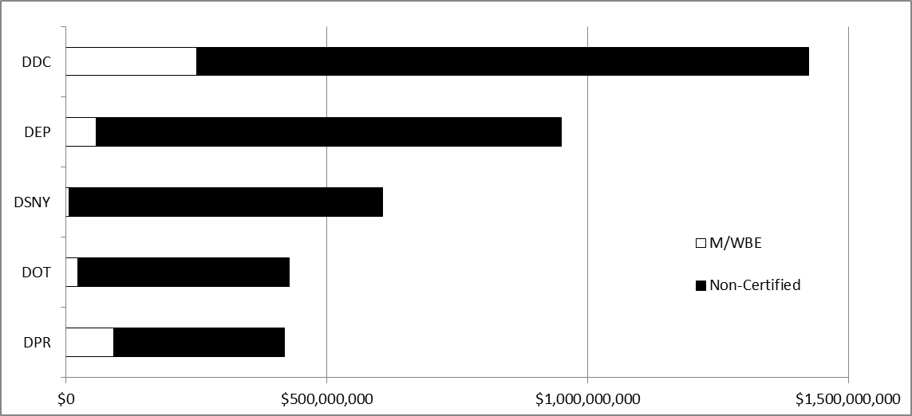
Total Prime Budget Subject to the M/WBE Program

FIGURE B:
FY16- Total Prime Awarded to M/WBEs and Non-Certified Firms by Agency*
*includes agencies with a total prime budget between $50million and $160million, subject to the M/WBE program
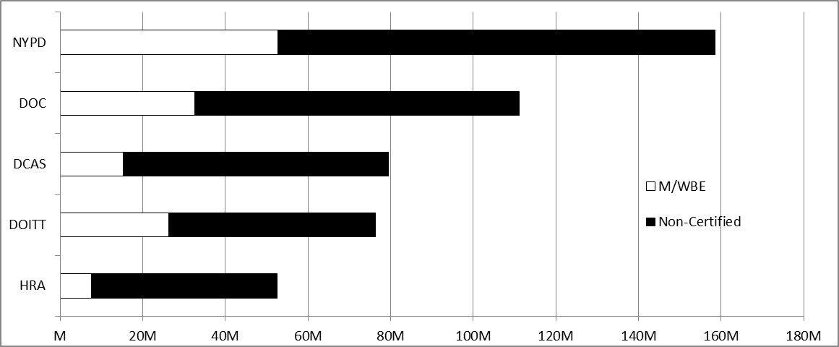
Total Prime Budget Subject to the M/WBE Program

FIGURE C:
FY16- Total Prime Awarded to M/WBEs and Non-Certified Firms by Agency*
*includes agencies with a total prime budget between $12million and $40million, subject to the M/WBE program
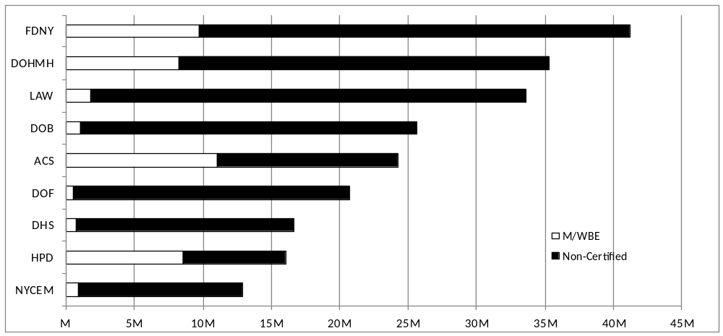
Total Prime Budget Subject to the M/WBE Program

FIGURE D:
FY16- Total Prime Awarded to M/WBEs and Non-Certified Firms by Agency*
*includes agencies with a total prime budget between $1million and $7.5million, subject to the M/WBE program
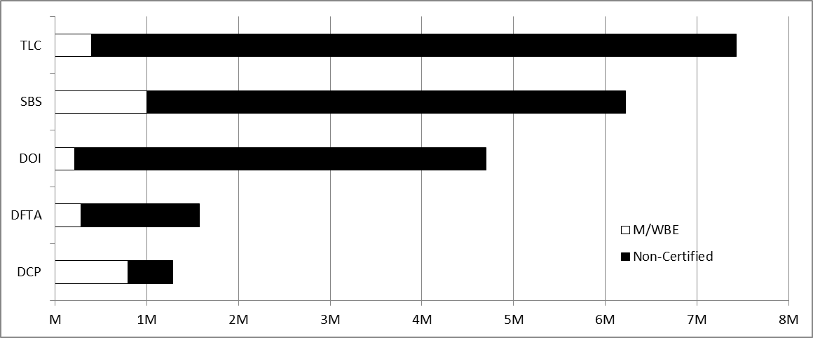
Total Prime Budget Subject to the M/WBE Program

FIGURE E:
FY16- Total Prime Awarded to M/WBEs and Non-Certified Firms by Agency*
*includes agencies with a total prime budget greater than190K but less than $1million, subject to the M/WBE program
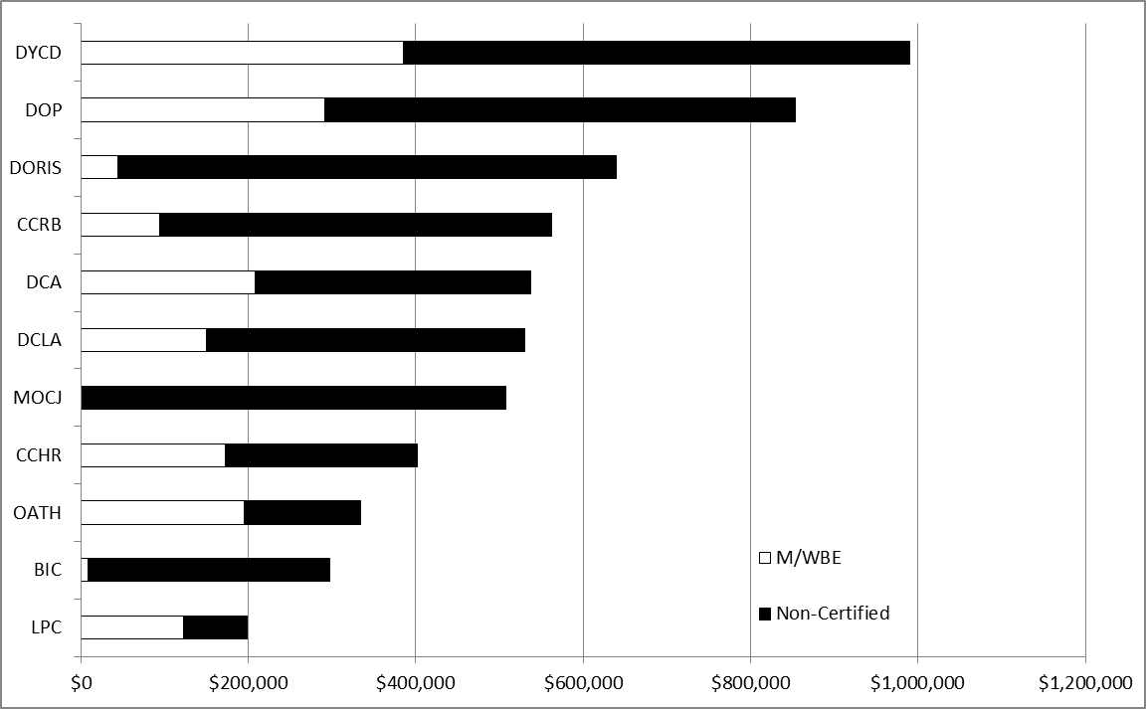
Total Prime Budget Subject to the M/WBE Program

FIGURE F:
FY16- Total Subcontracts on Primes Awarded to M/WBEs and Non-Certified Firms by Agency*
*includes agencies with a total of subcontracts on primes greater than $200million, subject to the M/WBE program.
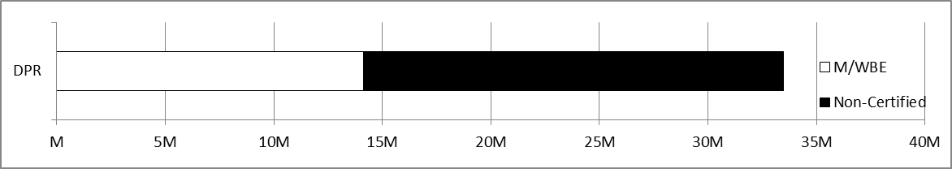
Total Subcontracts on Primes Subject to the M/WBE Program

TABLE F:
FY16- Total Subcontracts on Primes Awarded to M/WBEs and Non-Certified Firms by Agency*
*includes agencies with a total of subcontracts on primes greater than $200million, subject to the M/WBE program.
Total Subcontracts on Primes Budget Subject to the M/WBE Program

FIGURE G:
FY16- Total Subcontracts on Primes Awarded to M/WBEs and Non-Certified Firms by Agency*
*includes agencies with a total of subcontracts on primes between $30million and $50million, subject to the M/WBE program
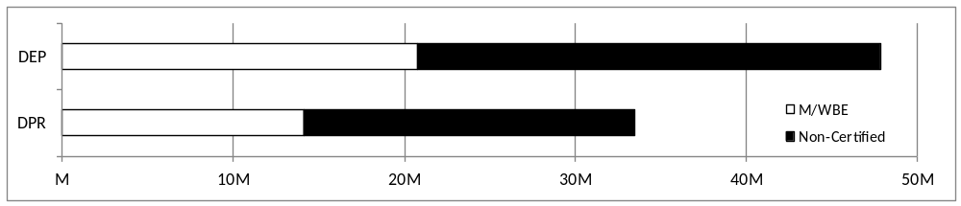
Total Subcontracts on Primes Subject to the M/WBE Program

FIGURE H:
FY16- Total Subcontracts on Primes Awarded to M/WBEs and Non-Certified Firms by Agency*
*includes agencies with a total of subcontracts on primes between $3million and $7.1million, subject to the M/WBE program
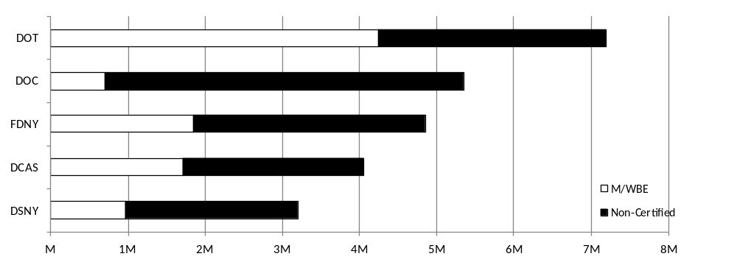
Total Subcontracts on Primes Subject to the M/WBE Program

FIGURE I:
FY16- Total Subcontracts on Primes Awarded to M/WBEs and Non-Certified Firms by Agency*
*includes agencies with a total of subcontracts on primes less than $600K, subject to the M/WBE program
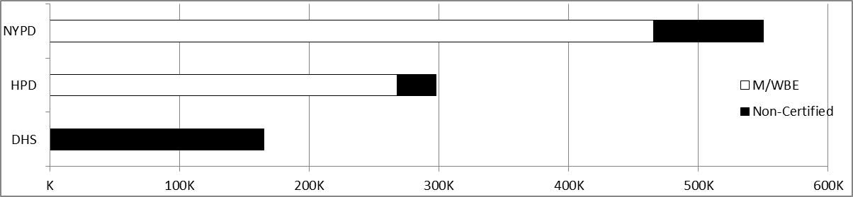Total Subcontracts on Primes Subject to the M/WBE Program

U.S. Small Business Administration, Small Business Profile: New York (2016), available at https://www.sba.gov/sites/default/files/advocacy/New_York.pdf
Pursuant to City of Richmond v. J.A. Croson Company, 488 U.S. 469 (1989), a United States Supreme Court case, a municipality may only create a race-based program if it demonstrates historical and societal discrimination against minority businesses.
L.L. 61/1991.
Mason Tillman Associates, Ltd., City of New York Disparity Study 11-3 (Jan. 2005), available at http://masontillman.com/sites/masontillman.com/files/attachments/1312%20City%20of%20New%20York%20Final%20REPORT%201-24-05.pdf
Id. at 11-4
Id.
Id.
Id. at 12-2
Id.
Id. at 10-4
Id.
L.L 129/2005
Id.
Id. The participation goals for this program were established as a result of the disparity study conducted by the City that examined the availability of M/WBEs as compared to their utilization in public contracting.
New York City Department of Small Business Services, “Minority and Women-owned Business Enterprise (M/WBE) Certification Program,” https://www1.nyc.gov/nycbusiness/description/minority-and-womenowned-business-enterprise-certification-program-mwbe (last visited December 1, 2016)
Office of the Mayor of the City of New York, Mayor Bloomberg Signs Legislation to Help Strengthen Minority and Women-Owned Business Enterprise Program (Jan. 7, 2013), available at http://www1.nyc.gov/office-of-the-mayor/news/011-13/mayor-bloomberg-signs-legislation-help-strengthen-minority-women-owned-business-enterprise
L.L. 1/ 2013
Id.
City of New York, Mayor’s Office of Contract Services, Agency Procurement Indicators: Fiscal Year 2016 (2016) available at http://www1.nyc.gov/assets/mocs/downloads/pdf/IndicatorsReport/2016AgencyProcurementIndicators.pdf pg. 5(hereinafter “Mayor’s Office of Contract Services, Agency Procurement Indicators 2016”)
Id.
Mayor’s Office of Contract Services, Agency Procurement Indicators 2016 available at http://www1.nyc.gov/assets/mocs/downloads/pdf/IndicatorsReport/2016AgencyProcurementIndicators.pdf pg. 11
Id. at 12
Id. at 12-13
Id. at 12
Id. at 13-14
Id.
See Appendix G, also See City of New York, Mayor’s Office of Contract Services, Agency Procurement Indicators: Fiscal Year 2015 (2015) available at http://www1.nyc.gov/assets/mocs/downloads/pdf/IndicatorsReport/2015%20Agency%20Procurement%20Indicators.pdf (last visited November 30, 2016)
Mayor’s Office of Contract Services, Agency Procurement Indicators 2016, supra note 16 See Appendix G and I available at http://www1.nyc.gov/site/mocs/resources/AppendicesIndicatorsFY16.page (last visited November 30, 2016)
Id. See Appendix G – Prime Contract M/WBE Utilization by Agency (herein after “Appendix G”)
Id. See Appendix G
Id. See Appendix G
Id. See Appendix G
Id. See Appendix G
Id. See Appendix I – MWBE Subcontracting on Primes (herein after “Appendix I”)
Id. See Appendix G
Id. See Appendix I
Id. See Appendix G
Id. See Appendix G
Id. See Appendix G
Id. See Appendix G
Id. See Appendix G
Id. See Appendix G and Appendix I
Id. See Appendix G and Appendix I
Id. See Appendix G
Id. See Appendix I
Id. See Appendix I
Id. See Appendix G and I
The Black Institute, “Not Good Enough: The Myth of Good Faith and Bad” 2015, available at https://d3n8a8pro7vhmx.cloudfront.net/theblackinstitute/pages/352/attachments/original/1428411258/TBI_MWBE_Report_040215_FINAL.pdf?1428411258 (last visited November 29, 2016).
N.Y. Gen. Mun. L. 103
N.Y. Gen, Mun. L 104-b
City of New York, Minority and Women-Owned Business Enterprise Program First and Second Quarters of Fiscal Year 2016 Compliance Report 13 (April 2016), available at https://www1.nyc.gov/assets/mocs/downloads/pdf/MWBEReports/April_1_Report_FY16_Final_Draft_wAppendix.pdf
Id.
The New York State Senate, S. 5924-A, https://www.nysenate.gov/legislation/bills/2015/S5924/amendment/A (last accessed Dec. 1, 2016)
Id.
Make New York Your Next Customer with Assistance from our Capacity-Building Programs and Services NYC Small Business Services http://www.nyc.gov/html/sbs/nycbiz/html/growing/growing.shtml
Contract Financing for NYC Small Businesses NYC Small Business Services http://www.nyc.gov/html/sbs/nycbiz/html/growing/nyc_construction_loan.shtml
Id.
Technical Assistance NYC Small Business Solutions http://www.nyc.gov/html/sbs/nycbiz/html/growing/technical_assistance.shtml
Id.
Id.
Id.
NYC Teaming NYC Small Business Services http://www.nyc.gov/html/sbs/nycbiz/html/growing/nyc_teaming.shtml
Capacity Building Services for Construction Firms NYC Small Business Services http://www.nyc.gov/html/sbs/nycbiz/html/growing/construction.shtml
Id.
NYC Goods & Services Mentorship Program NYC Small Business Services http://www.nyc.gov/html/sbs/nycbiz/html/growing/nyc_goods_services_mentorship.shtml
Id.
Strategic Steps for Growth Minority and Women-Owned Business Enterprise (M/WBE) Program NYC Small Business Services http://www.nyc.gov/html/sbs/nycbiz/html/summary/course_catalog_application_based.shtml#ssgmwbe
Id.
Id.
Corporate Alliance Program (CAP) NYC Small Business Services http://www.nyc.gov/html/sbs/nycbiz/html/summary/cap_info.shtml
Minority and Women Revolving Loan Trust Fund Program, Empire State Development https://esd.ny.gov/businessprograms/mwberevolvingloantrustfund.html
Id.
Id.
Id.
Minority-Owned Businesses U.S. Small Business Administration https://www.sba.gov/starting-business/how-start-business/business-types/minority-owned-businesses
Women-Owned Small Businesses U.S Small Business Administration https://www.sba.gov/contracting/government-contracting-programs/women-owned-small-businesses
De Blasio Administration Announces Over $1.6 Billion in Minority and Women-Owned Business Enterprise." The Official Website of the City of New York. 28 Sept. 2015 available at http://www1.nyc.gov/office-of-the-mayor/news/652-15/de-blasio-administration-over-1-6-billion-minority-women-owned-business (Last visited December 1, 2015)
Id.
Pursuant to N.Y. State Finance Law § 163, "Best value" means the basis for awarding contracts for services to the offerer which optimizes quality, cost and efficiency, among responsive and responsible offerers. Such basis shall reflect, wherever possible, objective and quantifiable analysis. Such basis may also identify a quantitative factor for offerers that are small businesses or certified minority- or women-owned business enterprises as defined in subdivisions one, seven, fifteen and twenty of section three hundred ten of the executive law to be used in evaluation of offers for awarding of contracts for services.
De Blasio Administration to Seek Amendments to State Law Help Increase Contracting to Minority and Women-Owned Businesses The Official Website of the City of New York. 15 May 2015 available at http://www1.nyc.gov/office-of-the-mayor/news/315-15/de-blasio-administration-seek-amendments-state-law-help-increase-contracting-minority (last visited December 1, 2015).
L.L. 114/2016
L.L. 113/2016
L.L. 109/2016
LL. 116/2016
L.L. 117/2016
L.L. 118/2016
Office of the Mayor of the City of New York, Mayor de Blasio Signs Legislation Increasing Transparency and Accountability Around M/WBE Contracting (Sept. 28, 2016), available at http://www1.nyc.gov/office-of-the-mayor/news/781-16/mayor-de-blasio-signs-legislation-increasing-transparency-accountability-m-wbe
Toure, M. (2016, September 28). De Blasio Announces 30 Percent MWBE Participation Goal After Harsh Review by Stringer. Retrieved November 28, 2016, from http://observer.com/2016/09/de-blasio-announces-30-percent-mwbe-participation-goal-after-harsh-review-by-stringer/
Id.
Nahmias, L. (2016, September 28). Amid criticism, de Blasio sets big goal for minority- and female-owned businesses. Retrieved November 28, 2016, from http://www.politico.com/states/new-york/city-hall/story/2016/09/de-blasio-sets-ambitious-goal-for-mwbe-contracting-105895
Office of the New York City Comptroller, Making the Grade 2016 (Nov. 17, 2016), available at http://comptroller.nyc.gov/reports/making-the-grade/reports/making-the-grade-2016
Id.
Id.
Id.
Bertha Lewis, “Maya Wiley’s Departure Reinforces Lack of M/WBE Progress,” City and State: NY Slant (July 5, 2016), http://nyslant.com/blog/blog/maya-wiley%E2%80%99s-departure-reinforces-lack-of-mwbe-progress.html
Mays, J, “De Blasio's Minority Contracting Plan Is 'Insulting,' Business Leaders Say - Central Harlem,” DNAinfo New York (November 12, 2015), https://www.dnainfo.com/new-york/20151112/central-harlem/de-blasios-minority-contracting-plan-is-insulting-business-leaders-say

